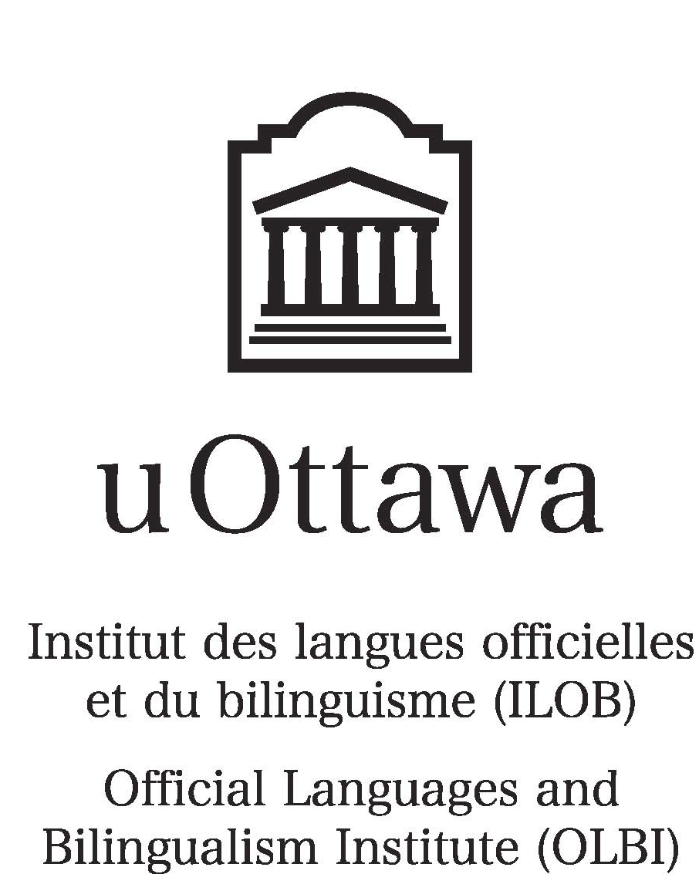

Proposal
Shanghai Jiao Tong University (SJTU)
Business English Program
Four Weeks
Summer 2010

Bianca Sherwood
Manager
Development and Promotion
Official Languages and Bilingualism Institute (OLBI)
Faculty of Arts
University of Ottawa
bsherwo@uottawa.ca

May 10, 2010

Table of Contents

Introduction 3
1. Background 3
1-1. Our City 3
1-2. Our Campus 3
1-3. Our Department 4
2. SJTU Business English Program at uOttawa 5
2-1. Program Scope 5
2-2. Tentative First-Day Program Schedule 5
2-3. Tentative Weekly Schedule 5
2-4. Course Cost 6
2-5. Accommodation 6
3. Our Faculty and Administration 6
3.1 OLBI Administrative Personnel 7
4. Campus Map 8

Introduction
The Official Languages and Bilingualism Institute (OLBI) at the University of Ottawa has been offering instruction in English or French as a second or foreign language for more than two decades. We welcome opportunities to provide tailor-made programs to students from a variety of countries around the world, and would indeed be pleased to offer an intensive Business English program to students from Shanghai Jiao Tong University (SJTU). The following provides some background information on OLBI and its environs, gives an overview of the proposed SJTU program and its costs, and provides an introduction to some of our administration and faculty.

1. Background

1-1. Our City
Described as one of the most beautiful cities in the world, Ottawa offers not only a wide variety of urban attractions but also easy access to spectacular parks and wilderness. Visitors can enjoy many of Canada’s best theatre companies, symphonies, music festivals, and museums or walk the trails that hug a canal joining two historic rivers.

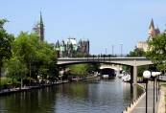
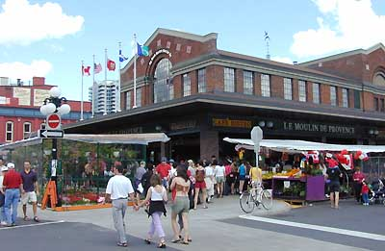

Parliament Buildings Rideau Canal By Ward Market
As Canada’s capital, Ottawa also has a thriving business community that collaborates with all levels of government and education. More than 1,500 companies are involved in key industries such as telecommunications, software, photonics, defense, tourism, wireless technologies, multimedia, professional services, and environmental technologies.

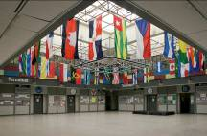
1-2. Our Campus
Located in the heart of the city, the University of Ottawa has a total population—including students, teachers, and support staff—of 36,000. With more than 360 undergraduate programs and more than 110 graduate programs in 10 faculties, the University attracts students not only from across Canada but also from more than 100 countries around the world. The
UUniversity Centre Terminus
University of Ottawa is one of the top 10 research institutions, ranking 7th out of 50. Faculties such as the School of Information Technology and Engineering, Telfer School of Management, Health Sciences, Medicine, and Science, among others, contribute to the University’s reputation as a vibrant institution for research and learning.

Many resources and activities are available on campus:
- Multipurpose computer facilities
- State-of-the-art language laboratories and multimedia classrooms
- Extensive library system
- Regularly scheduled concerts, plays, festivals, and films

For more information, visit
www.uOttawa.ca
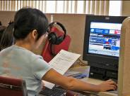
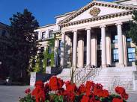
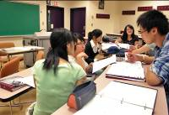

Language Lab Tabaret Hall Multimedia Classroom

1-3. Our Department
Under the umbrella of the Faculty of Arts, the Official Languages and Bilingualism Institute (OLBI) has been a center for research in second-language acquisition and pedagogy for more than two decades. Each year, hundreds of students from countries around the world choose our programs, whose teachers are highly qualified specialists in second-language instruction. OLBI has offered many custom-designed programs for special groups, including pre-MBA students from China, English teachers from Japan, information technology educators from Korea, and pilots from Algeria.
For more information, visit
www.olbi.uottawa.ca

2. SJTU Business English Program at uOttawa

2-1. Program Scope
The SJTU Business English Program at the University of Ottawa will host a minimum of 16 undergraduate students for four weeks. The objective of the program is to enhance their language skills in the context of a global English-speaking business environment. The content-based program will offer a range of integrated skills, writing, and oral communication courses revolving around current business issues such as global marketing, international trade, organizational behavior, business ethics, and information technology. Occasional guest speakers and corporation/organization visits will round out the program. At the end of the program, students will receive a certificate showing successful completion.

2-2. Tentative First-Day Program Schedule
Tentative first-day activities will include registration, a campus tour, and a welcome reception.
TIME | EVENT
8:30 -9:00 | Meet Bianca Sherwood, Manager, Development and Promotion  600 King Edward Avenue, Room 204
9:30 | Registration
9:30-11:30 | Needs/Skills assessment
11:30-1:00 | Official welcome  Welcome reception
1:00-3:00 | Campus tour  Student cards
* Schedule is subject to change.

2-3. Tentative Weekly Schedule
The weekly schedule will follow a fairly intensive agenda of custom-designed Business English instruction:
MONDAY | TUESDAY | WEDNESDAY | THURSDAY | FRIDAY
A.M.  Integrated  Skills: Current Issues in Business | A.M.  Writing for  Business | A.M.  Integrated  Skills: Current Issues in Business | A.M.  Oral Communication  for Business | A.M.  Integrated  Skills: Current Issues in Business
Lunch | Lunch | Lunch | Lunch | Lunch
P.M.  Business in the News (language lab/guest speaker) | P.M.  Focus on Business Vocabulary | P.M.  Business in the News (language lab/corporation visit) | P.M.  Socio-cultural Outings | P.M.  Independent  Study
* Schedule is subject to change.

2-4. Course Cost
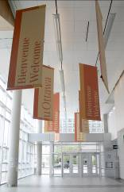
Based on a class of 16 students, the cost of the four-week course is $1,500 per participant. This includes
- Tuition
- Textbook
- Materials
- Welcome and farewell receptions
- Airport pick-up and drop-off
- Complimentary residence accommodation
for one accompanying professor per class
* Socio-cultural outings, if desired, will cost an additional
$100 per participant.

2-5. Accommodation
Desmarais Hall
During their stay in Ottawa, participants will live in our new residence located on campus. Each two-bedroom unit includes
- A bathroom
- A kitchenette with a microwave, fridge, kitchen table and chairs
- A desk, chair, dresser, double bed and television (cable included) in each bedroom
- Seasonal air-conditioning with a control in each unit
- Individual telephones with voicemail
- Internet access
- Access to laundry, kitchen, study, and lounge facilities
The cost of residence is approximately $25 per night per participant. This fee is subject to change and does not include meals. Participants may eat at one of the many cafés on campus or will enjoy preparing their own meals and shopping for fresh produce and food at the farmer’s market and high-quality supermarkets only a few blocks away.

3. Our Faculty and Administration
The Official Languages and Bilingualism Institute is the flagship of bilingualism in Canada and a centre for research in second language acquisition and pedagogy. Accredited by Languages Canada, the Institute has approximately 20 full-time and 60 part-time faculty, all of whom are highly trained in teaching a second language, either English or French. A master’s degree in teaching English or French as a second language and several years’ teaching experience are minimum requirements for our instructors.

3.1 OLBI Administrative Personnel
- Richard Clément, PhD, Director, OLBI, rclement@uottawa.ca
- Lise Bazinet, Assistant Director, Development and Promotion, lbazinet@uottawa.ca
- Bianca Sherwood, Manager, Development and Promotion, bsherwo@uottawa.ca
- Rebecca Coulombe, Academic Counsellor, rebecca.coulombe@uottawa.ca
- Melanie Cossette, Marketing Officer, melanie.cossette@uottawa.ca
- Céline Mounzer, Administrative Assistant, Development and Promotion, cmounzer@uottawa.ca
- Sheila Hyatt, Clerk, Development and Promotion, shyatt@uottawa.ca

4. Campus Map
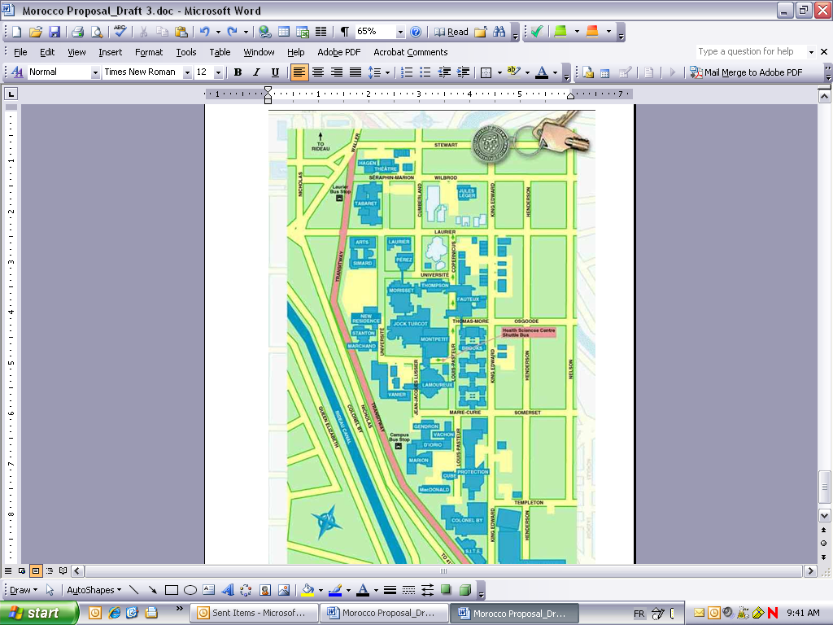

University of Ottawa
Campus Map

New Residence
INFOSERVICE
Official Languages and Bilingualism Institute

(600 King Edward)

